

Gabriel’s horn

Teddy Rocks Maths Essay Competition



March 10, 2022

Teletta Groß Gymnasium

GAßWERKSTRAßE 17, 26789 Leer, Germany

*How to handle this document?*

* Italic words written in this colour are in the glossary.
* Non-italic words with colour correspond to the pictures they are mentioned in – some words don’t have an image they belong to, but are still coloured, hence they are important for the context.
* If parts of a formula are squared in, it means that they or their places change inside the formula, while the formula gets refined.

***How mathematics allows us to have something finite in something infinite***

# Many do not associate the Bible with mathematics, but one story teaches us otherwise. The story of the angel Gabriel and his horn, with which he announces the last judgment, as described in the Christian religion.

To be honest, we won’t find a word of Gabriel’s Horn in terms of maths, however, *Evangelista Torricelli* described a body, which is shaped like a horn and has an infinite surface area, hence the name which later came to be. He himself published this in 1643 under another name in his paper "De solido hyperbolico acuto", where he called this shape a truncated acute hyperbolic solid. He was not the first to describe such a body, however. *Nicole Oresme* had a similar idea in the 14th century, but we’ll concentrate on the work of *Evangelista Torricelli*.

# If I asked you to tell me the volume of this body, you’ll most likely say that it’s infinite, which is a reasonable guess, since it has an infinite surface area. However, you are wrong, which is fine, hence this is the purpose of me writing this, so you get to understand the maths behind this paradox of a body having a finite volume, even though it has an infinite surface area.

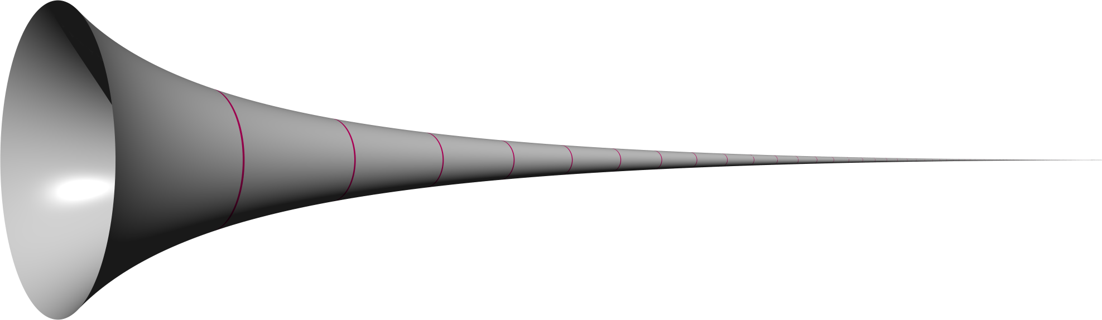First, you should know how such a body is created. Basically, it’s just the function of y *= 1/x* with the *domain* x ≥ 1. Around the point 1|1 we now just need to rotate the graph about the x-axis to create such a *solid of revolution*.

# Diagram Description automatically generatedKnowing this, we will begin approaching the maths behind the volume and the surface area, and you will see how wonderful mathematics can really be when you have a great topic to work with:

We’ll start solving this problem by calculating the volume of revolution step by step using an*integral* just like using it to calculate the area under a curve, by slicing up the body into thin slices and adding them together, basically *calculus*.

If you now look at one slice, you’ll probably see that it looks like a cylinder with the sides inclining. To calculate its volume, we’ll need the formula to calculate the area of its face and then just multiply it by its height. This means π * r²(r = radius) for the circle beneath and this is multiplied with the height dx, and we’ve got the volume of these slices, which are always getting smaller in terms of the height, which means that we need to build an *integral* into the formula.

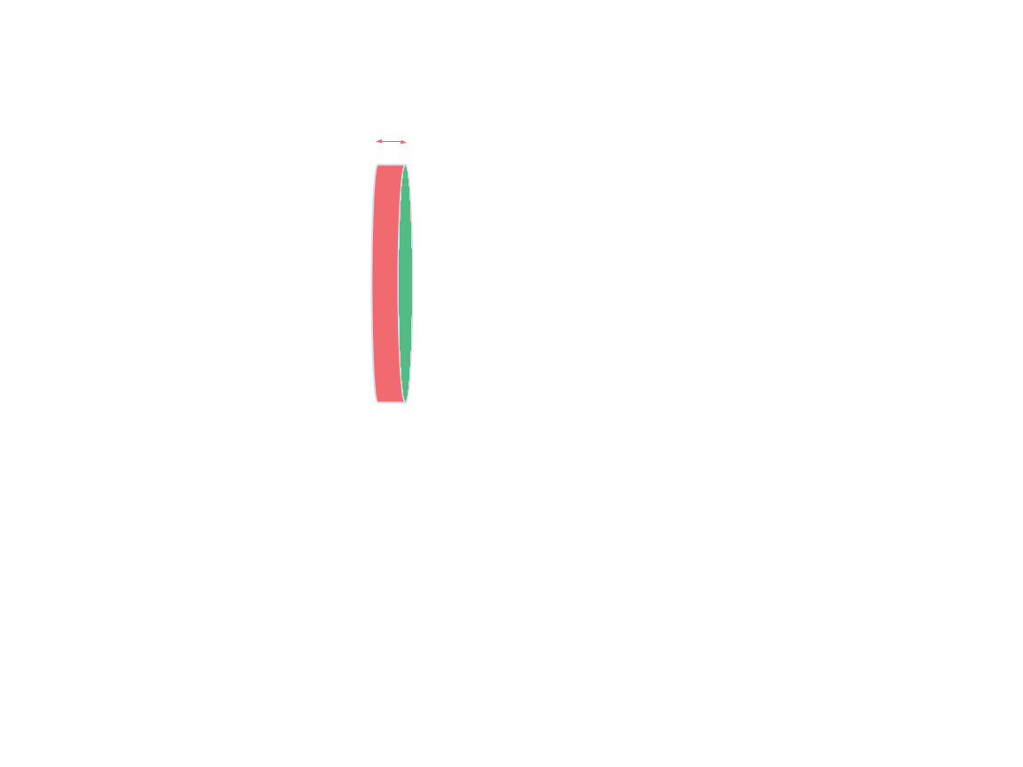

dx

Height

Area of the face

$$π⋅r^{2}$$

r

The face of the cylinder (2D)

# Letting the height dx go to 0 while also adding all the cylinders together will give us our *integral*. Since we start at 1|1 and let the curve go down to infinity (∞), the integral looks like this:

$$\int_{1}^{∞}{}$$

Adding the height, the formula for the face of the cylinder and the *integral* will give us our basic formula to calculate the volume:

$$\int_{1}^{∞}{π⋅r^{2}⋅ⅆx}$$

Before solving this, however, one step is needed to complete the formula so that we can properly calculate the volume. Making a definite *integral*, hence the radius r always changes depending on the point, where the slice is being taken from, as seen in the picture below. Coming to this realisation means that we need something else instead of the radius r, something that changes depending on the position. This something is given by the graph itself, the value y, which is the radius when we look at it from the x-axis.

With this knowledge, we can make the formula properly solvable:

|

# Let us now get to solving this by integrating the formula with the help of the limit notation of *calculus*. Putting first things first we need to form the *antiderivative* by adding 1 to the exponent and then dividing through it, however here we have x as the denominator in the fraction, which means that we here have x–¹.

$$\int_{1}^{∞}{π⋅\frac{1}{x^{2}}⋅ⅆx}=π⋅\lim_{n→∞}\int_{1}^{n}{\frac{1}{x^{2}}ⅆx}= π⋅\lim_{n→∞}\int_{1}^{n}{x^{-2}ⅆx}$$

$=π⋅\lim_{n→∞}{\left[-x^{-1}+k\right]}_{1}^{n}ⅆx= π⋅\lim_{n→∞}{\left[-\frac{1}{x}+k\right]}_{1}^{n}ⅆx$

$= π⋅\left(\lim_{n→∞}\left(-\frac{1}{n}+k\right)-\left(-\frac{1}{1}+k\right)\right)= π⋅\left(0+1\right)$

$= π$

Having solved this, the maths talks for itself, the volume of Gabriel's Horn is equal to π or rather the volume will never transcend π, although it gradually draws nearer to π as n increases. This just means that the volume approaches π as n approaches infinity.

# What is left now is to find out the formula for the surface area, by again looking at one slice. This time, however, not at what can fit in it, but what we can put around it.

To make it easier to understand, we need to roll out this *Conical Frustum* and what we see is an *annulus*. We need the length of the inner curve a (circumference) and the height (b) to calculate its surface area.



Having all of this is enough to get the basic formula to calculate the surface area of Gabriel's Horn. We just need to plug in all the variables into the formula by integrating to ds and having r as 1/x once again as the radius, which brings us to:

Now we need to somehow deal with that ds by looking at it as being a right triangle with a little bend. The bend, which is the hypotenuse is the value ds from before, dx is the value you get by looking at the x-axis so the lower side, dy is the vertical value which means that it is the side facing upwards.

Now, it is possible for us to use the *Pythagoras theorem* since we know that ds² is equal to dy² + dx². We need to factor out the dx out of the typical square root function, which brings us to the value of ds, while also getting some true values for the variables inside.

Since we factored out the dx, a 1 is being left behind in its place.

$ⅆs^{2}=ⅆx^{2}+ⅆy^{2}$

$ⅆs^{2}=\sqrt{dx^{2}+dy^{2}}$

$ⅆs^{2}=\sqrt{1+{\left(\frac{ⅆy}{dx}\right)}^{2}}⋅ⅆx$

The true value we get belongs to (dy/dx)², hence y is equal to 1/x, which means that by differentiating dy/dx we get the value -1/x².

$y=\frac{1}{x}|\frac{ⅆx}{ⅆy}=\frac{-1}{x^{2}}|{\left(\frac{ⅆx}{ⅆy}\right)}^{2}=\frac{1}{x^{4}}$

This means, that we can get back to solving the integral since we have a value for ds, which is x. Knowing this means having the limit between 1 and infinity (∞), once again. Taking this into occasion means having to change the function, so it is solvable, just like we did it with the function of the volume – taking the 2π outside, adding the limits 1 and infinity (∞) to the integral and adding the function above in place of the ds, hence we used the *Pythagoras theorem* to calculate ds², which makes it obsolete:

$$A=\int{2⋅π⋅\frac{1}{x}⋅ⅆs}$$

$A=2 ⋅ π\int_{1}^{∞}{ \frac{1}{x}⋅ ds}$

$A=2 ⋅ π\int_{1}^{∞}{\frac{1}{x} \sqrt{1+\frac{1}{x^{4}}}ⅆx}$

What’s left for us to do now is to prove that the Surface Area is infinite. For this, we first inspect the square root inside the function. Looking at it now, you might see that its value is always bigger than 1, hence you always add a value x, which fits into the limit of 1 to ∞, after that, you just add one and then take the square root of it, which always leads to a value >1. This means, that we can replace the square root with 1 since the value exceeds it every time – to write it we just need to say, that the value of the surface area is always bigger than 2π times the integral of 1 to infinity, times 1 over x, times 1, times dx:

$$A>2 ⋅ π\int_{1}^{∞}{\frac{1}{x}⋅1⋅ⅆx}$$

$$→A>2 ⋅ π\int_{1}^{∞}{\frac{1}{x}⋅ⅆx}$$

$$x=ϵ\left[1,∞\right]$$

# What we have just done is create a definite *integral*, which means, that we can solve it properly. The 2π just stays where it is. Now however, we need to do the integral of 1 over x, which is just the natural logarithm of x between ∞ and 1. The natural logarithm of ∞ is ∞, since e∞ = ∞ or rather log(e) ∞ if the base is >1. Having solved this means that we have come to our conclusion, the surface area is infinite.

$$A=2π\int_{1}^{∞}{\frac{1}{x}ⅆx}=2π{\left[\ln{x}\right]}_{1}^{∞}→∞$$

# There is another way to come to this conclusion, using the limit notation once again. We don’t need to change a lot – just the limit ∞, by replacing it with another variable (n), which brings us to:

$$A=2 ⋅ π\int_{1}^{n}{\frac{1}{x}\sqrt{1+\frac{1}{x^{4}}}ⅆx}$$

$$→A>2 ⋅ π\int_{1}^{n}{\frac{1}{x}⋅ⅆx}$$

Using this function also brings us to the same logarithm, here however we part ways from the approach above, hence now we use limits to say, that the *lower bound* of the function is 2π times the natural logarithm of n, but there doesn’t exist an *upper bound* for the function as n approaches infinity.

$$\lim_{n→∞}A≥\lim_{n→∞}2π\ln\left(n\right)=∞$$

Having explored both ways of approaching the surface area means that we have now truly been able to solve the problem, which concludes with the mathematical part of this document. Left now is the paradox behind this, the so-called painter’s paradox.

# The painter’s paradox goes as follows:

The outer surface of Gabriel’s Horn is infinite, the volume is finite.

Therefore, you need an infinite amount of paint to paint the outer surface of Gabriel’s Horn. The volume is finite, which means that you need to pour a finite amount of paint (π amount of paint) into Gabriel’s Horn and then just empty it, to have painted the inner surface of Gabriel’s Horn.

Now you have learned everything important there is to know about the topic of Gabriel’s Horn. The maths as well as the history and the paradox itself. I tried to do this as well as possible, even though many don’t like maths. If this is the case, I still hope you have had fun reading this and I most of all hope, that you have understood this.

* *Lorenz Rutkevich*

# **Glossary:**

# **Antiderivative.** In calculus, an antiderivative is a differentiable function F whose derivative is equal to the original function f.

**Calculus.** Calculus describes the study of change and is one of the main branches of mathematics.

***Conical Frustum.*** A part of a solid lying between one or two parallel planes.

# **Domain.** The domain of a function is the set of input you can plug into a function.

**Evangelista Torricelli.** Evangelista Torricelli was an Italian physicist and mathematician who was born on the 15th of October 1608 and died on the 25th of October 1647. He was a student of Galileo Galilei.

**Integral.** In simple terms, an integral assigns numbers to a function.

**Lower Bound.** The smallest value that would round up to the estimated value.

**Nicole Oresme.** Nicole Oresme was a French philosopher who was born in 1325 and died in 1382.

**Pythagoras Theorem.** Pythagoras was an Ionian Greek philosopher who was born in 570 and died in 495 BC. His teachings are still known all over the world.

**Solid of Revolution.** A solid figure is a figure created by rotating a plane curve around a straight line in the same location.

# **Upper Bound.** The highest value that would round up to the estimated value.

# *References*:

Copyrighted images have been used in this essay under Fair Use as:

1. They illustrate an educational article about what the images represent.
2. The images are used as the primary means of visual identification of the article topic.
3. Images are at a low resolution.
4. Their inclusion in the article adds significantly to the article because the images shown are the object of discussion in the article.

This includes the first and second image used.

The included knowledge was taken from multiple sources:

[1]

Numberphile, *Gabriel’s Horn Paradox - Numberphile*, (Feb. 18, 2021). Accessed: Mar. 7, 2022. [Online Video]. Available: <https://www.youtube.com/watch?v=yZOi9HH5ueU>

[2]

C. Wijeratne and R. Zazkis, “On Painter’s Paradox: Contextual and Mathematical Approaches to Infinity,” *Int. J. Res. Undergrad. Math. Ed.*, vol. 1, no. 2, pp. 163–186, Jul.2015, doi: [10.1007/s40753-015-0004-z](https://doi.org/10.1007/s40753-015-0004-z).

[3]

E. W. Weisstein, “Gabriel’s Horn.” <https://mathworld.wolfram.com/> (accessed Mar. 17, 2022).

[4]

Jean S. Joseph, “Gabriel’s Horn.” <https://www.palmbeachstate.edu/honors/Documents/jeansergejoseph.pdf> (accessed Mar. 10, 2022)

[5]

“Gabriel’s Horn,” *Wikipedia*. Feb. 03, 2022. Accessed: Feb. 18, 2022. [Online]. Available: <https://en.wikipedia.org/w/index.php?title=Gabriel%27s_Horn&oldid=1069601796>